**Description**

As a user, If I Need help to guide through the application or have general questions, I should be able to go on the Footer Section and click on the Help Link and be directed to that page.

------------------------------------------------------------------------------------------------------------------------------------------



⇧

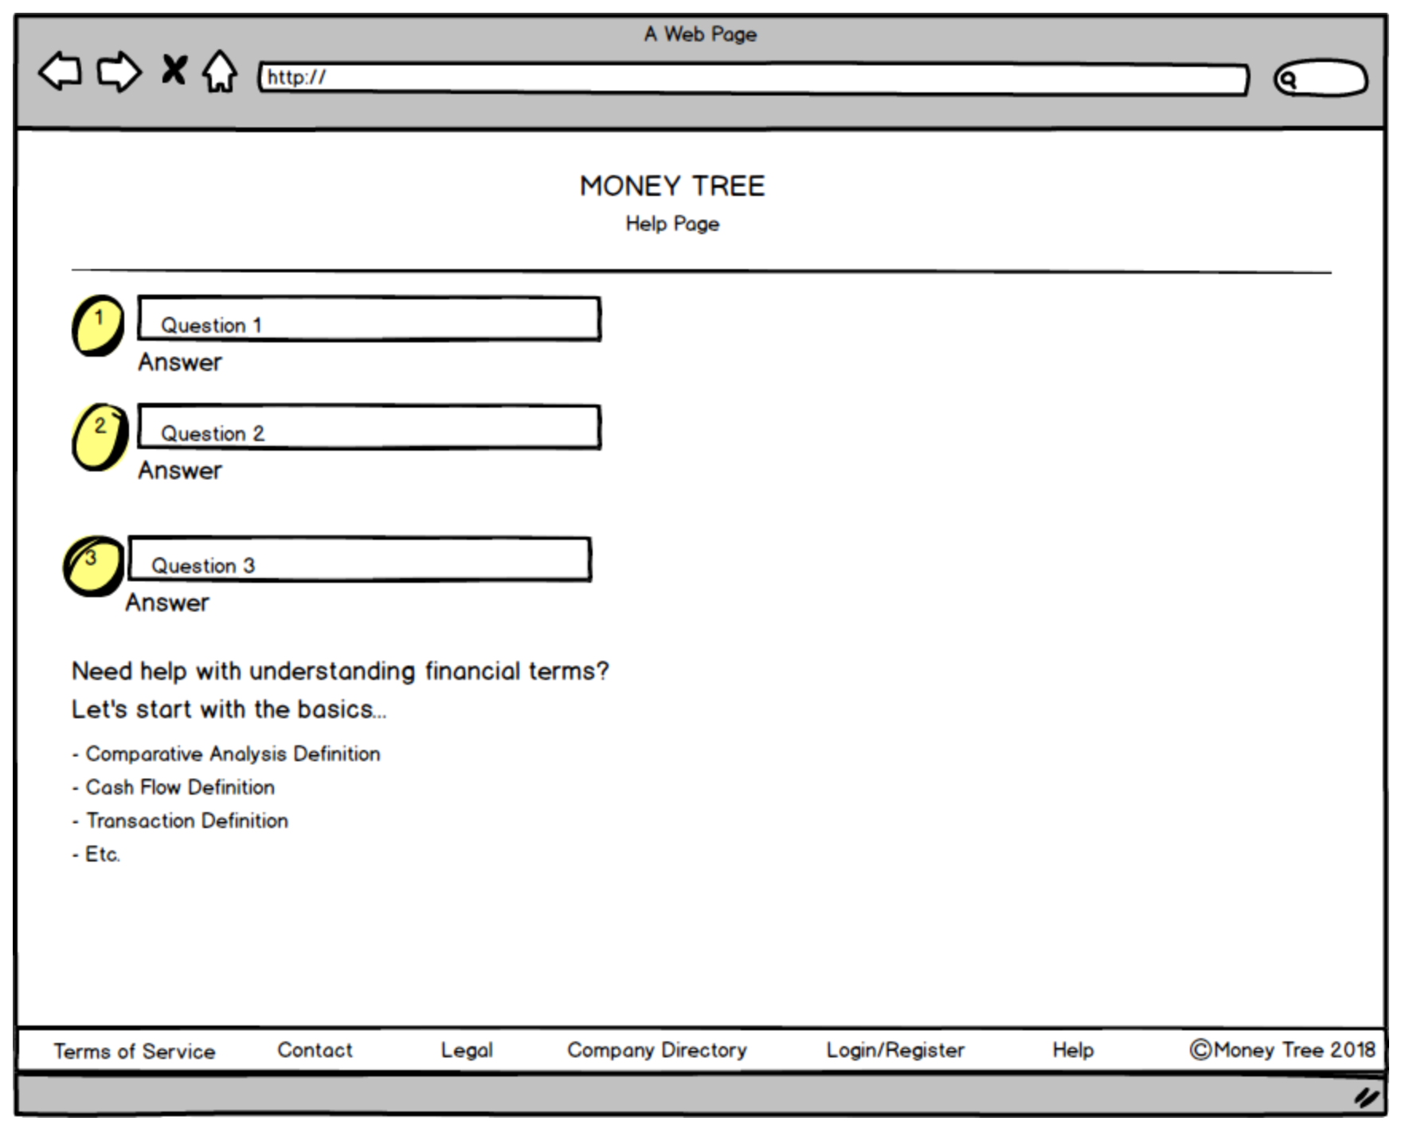

**Acceptance criteria**

* Display Frequently Asked Questions section
* Have an Education section – with financial terms being defined